DEPARTMENT OF COMPUTER SCIENCE

RAJAGIRI COLLEGE OF SOCIAL SCIENCES

(Autonomous)
KALAMASSERY - KOCHI - 683104



MASTER OF COMPUTER APPLICATIONS

DBMS LAB RECORD

MERIN JAI
NAME : __________________________

SEMESTER : __________________________

REGISTER NO. : __________________________

DEPARTMENT OF COMPUTER SCIENCE

RAJAGIRI COLLEGE OF SOCIAL SCIENCES

(Autonomous)
KALAMASSERY - KOCHI - 683104

MASTER OF COMPUTER APPLICATIONS

DBMS

LAB RECORD

MERIN JAI
NAME : __________________________

SEMESTER : __________________________

REGISTER NO. : __________________________



DEPARTMENT OF COMPUTER SCIENCE

RAJAGIRI COLLEGE OF SOCIAL SCIENCES

(Autonomous)

KALAMASSERY - KOCHI – 683104

MASTER OF COMPUTER APPLICATIONS

CERTIFICATE

MERIN JAI

NAME : _______________________

SEMESTER : _______________________

REGISTER NO. : _______________________

Certified that this is a bonafide record of work done by the student in the Software Laboratory of Rajagiri Department of Computer Science, Kalamassery.

Faculty in Charge Dean, Computer Science

Internal Examiner External Examiner

Place : Kalamassery
Date :

Table of Contents

Activity Page No

- E-R Diagram & Table Design

- Practice SQL Data Definition Language(DDL) commands
  - Table creation and alteration

- Practice SQL Data Manipulation Language (DML) commands
  - Row insertion, deletion and updating
  - Retrieval of data (Simple select query and select with
where options (include all relational and logical operators)
  - Functions: Numeric Data, Character Conversion and
  - Group functions
  - Data manipulations using date functions
  - Set Operations
  - Illustration of Group by Having Clause
  - Sub Queries
  - Retrieving from multiple tables
(Illustrate with Join Clause also)
- SQL Views
- Practice PL/SQL
  - Introductory programs
  - Illustration of Cursors
  - Illustration of Procedures
  - Illustration of functions
  - Illustration of Triggers

Activity # 1
ER Diagram & Table Design

Description :
- E-R Diagram and table reduction
- Table descriptions
Date :
ER Diagram & Table Design

Table name: Directors
Description: Used to store Directors Information

Attribute | Data Type | Constraints
DId | Int | Primary Key/ Not Null
Name | Varchar2(40) | Not Null

Table name: Stars
Description: Used to store Stars Information

Attribute | Data Type | Constraints
SId | Int | Primary Key/ Not Null
Name | Varchar2(40) | Unique
About | Varchar2(100)
Table name: Movies
Description: Used to store Movies Information

Attribute | Data Type | Constraints
MId | Int | Primary Key/ Not Null
Title | Varchar2(40) | Not Null
R_date | Date
Image_url | Varchar2(100)
Certificate | Varchar2(20)
Runtime | Number(3,2)
ImdbRating | Number (3,1) | By default 0
Description | Text(100) | By default Null
Metascore | Number (3,1) | By default 0
Votes | Int | By default 0
Gross | Number(10,2) | Gross amount should be greater than 10000

Table name: MoviesDirectors
Description: Used to store Movie Directors Information

Attribute | Data Type | Constraints
MoviesId | Int | Foreign Key references  Id of Movies table | Primary Key
DirectorsId | Int | Foreign Key references  Id of Directors table | Primary Key

Table name: MoviesStars
Description: Used to store Movie Stars Information

Attribute | Data Type | Constraints
MoviesId | Int | Foreign Key references  Id of Movies table | Primary Key
StarsId | Int | Foreign Key references  Id of Stars table | Primary Key

Activity # 2
Practice SQL Data Definition Language(DDL) commands

Description : 2.1 Table creation and alteration
Date :
Query
      - Create the tables based on the above description.

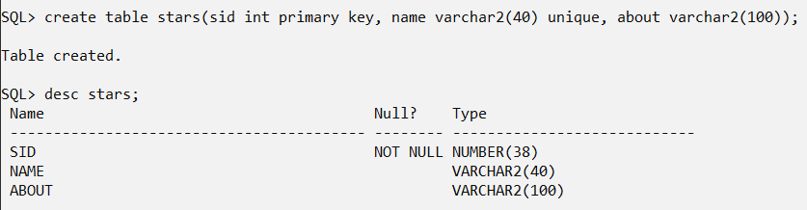

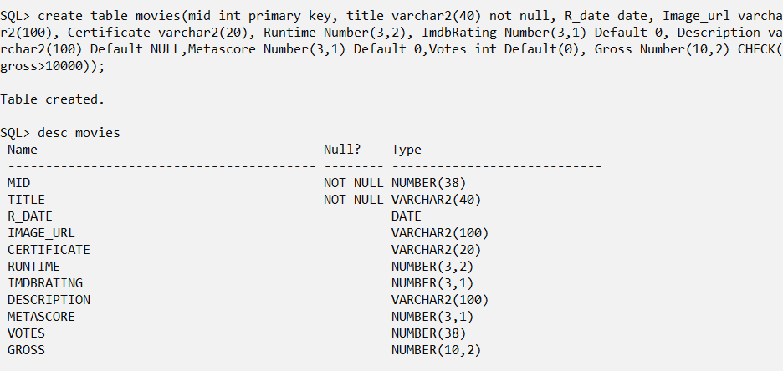

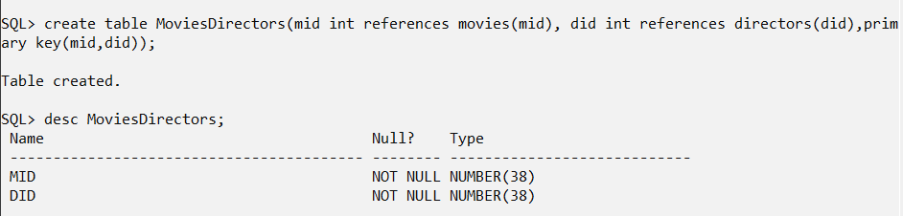

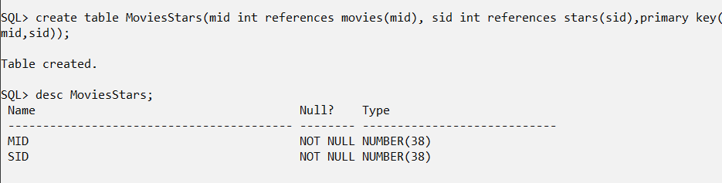

      - Add a column ‘DOB’ to Stars table.

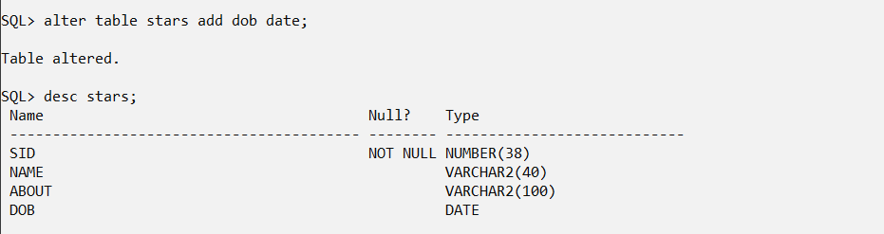

      - Drop the column ‘Gross’ in Movies table.

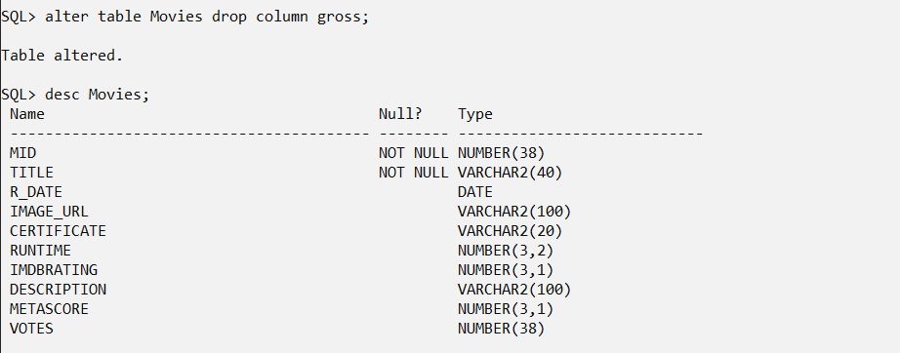

      - Add column ‘Language’ in Movies table.

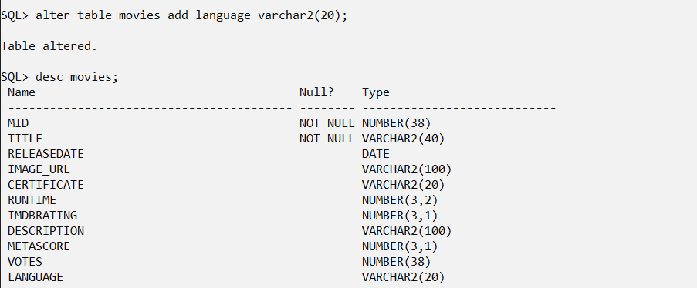

      - Add column Gross Number(10,2) in Movies table

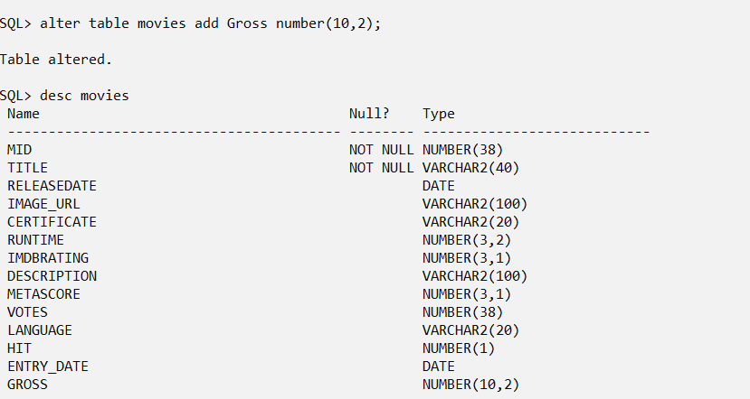

      - Change the name of the column ‘R_date’ in Movies table to Releasedate. Releasedate.

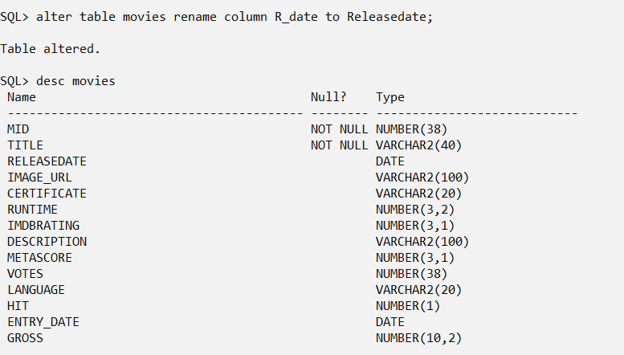

      - Add a column ‘Age’ in Directors table as Number. Age must be 7 years or above.

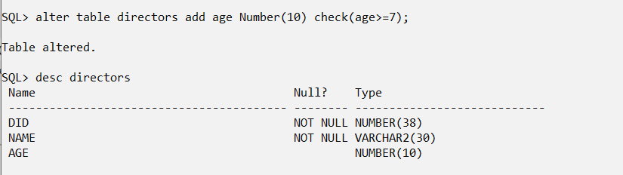

      - Add a new column ‘Hit’ in Movies table with datatype Number(1) and by default 0.

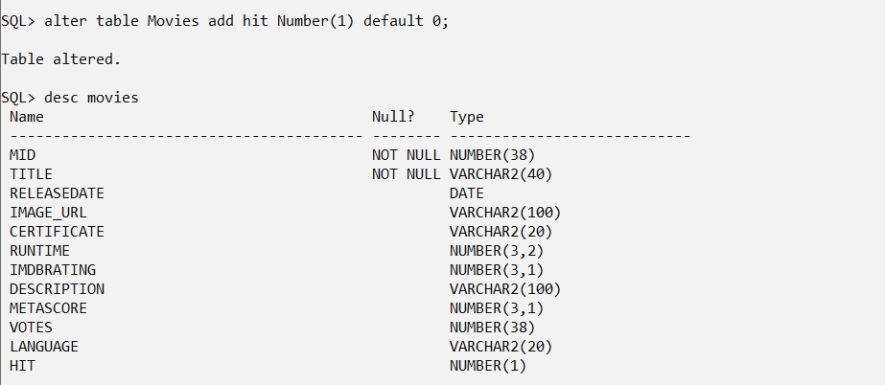

      - Add a new column ‘Entry_date’ in Movies table to record the date on which the movie details are entered in the data base.

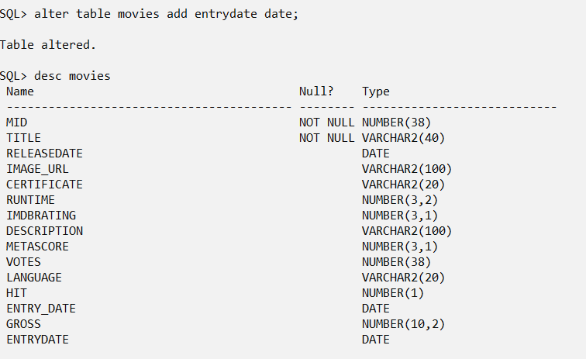

      - Destroy the table MoviesStars and recreate it.

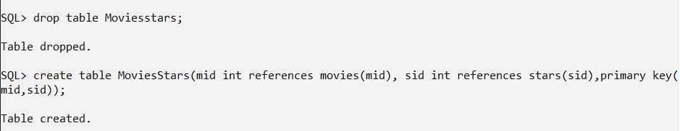

      - Change the size of the Director’s name to 30.

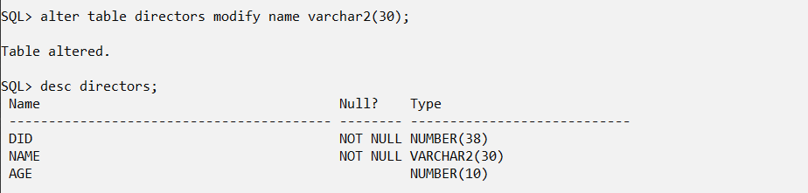

      - Add the following check constraints:
  - Releasedate should be less than the Entry_date in the Movies table.

  - Language of movies should be Malayalam, English, Tamil or Hindi.

Activity # 3
Practice SQL Data Manipulation Language (DML) commands

Description : 3.1 Row insertion, deletion and updating
Date :
Query
- Insert the appropriate data (10 rows) for the tables with respect to defined datatypes, size and constraints.

Movies table
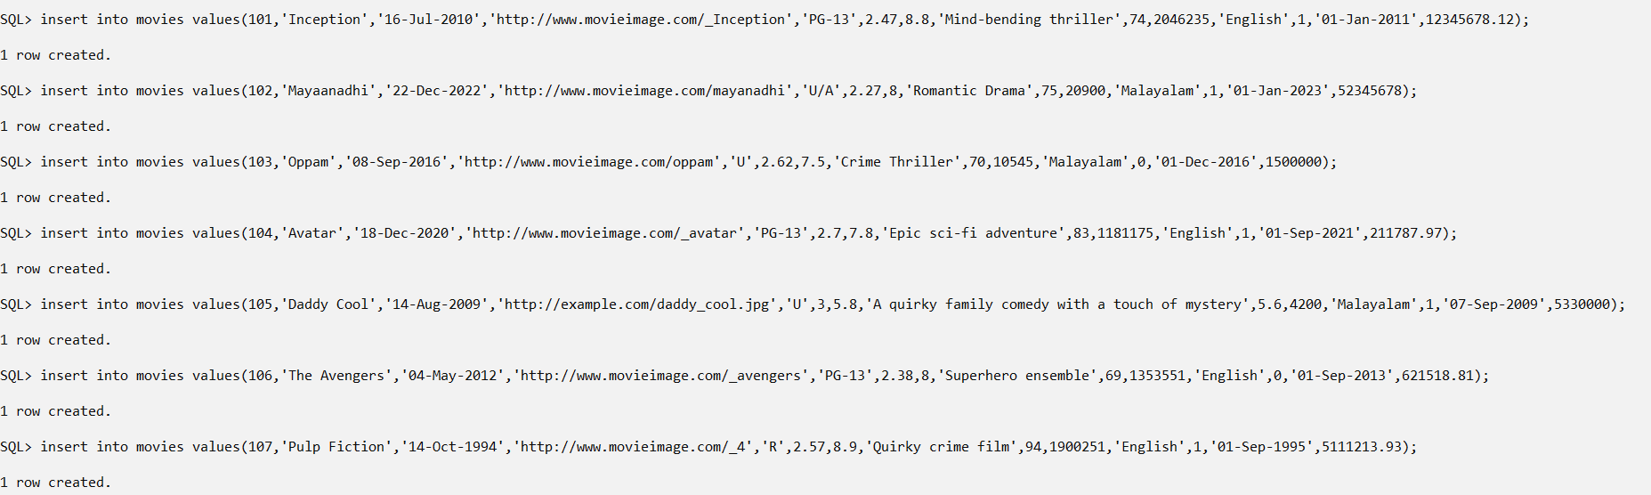

Directors Table
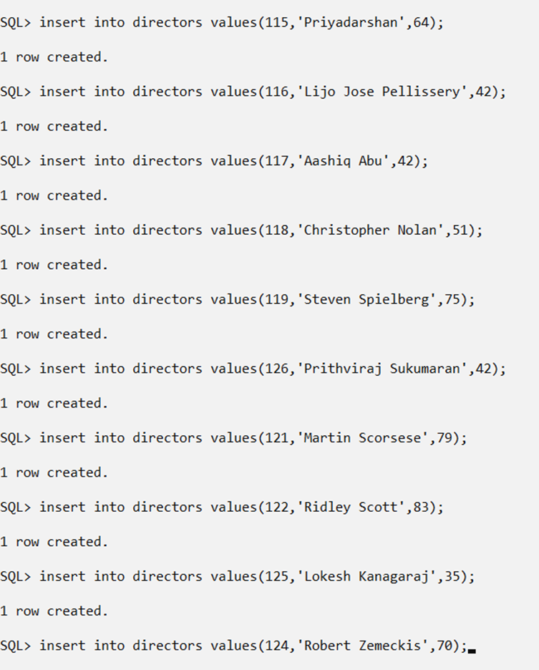
Stars table
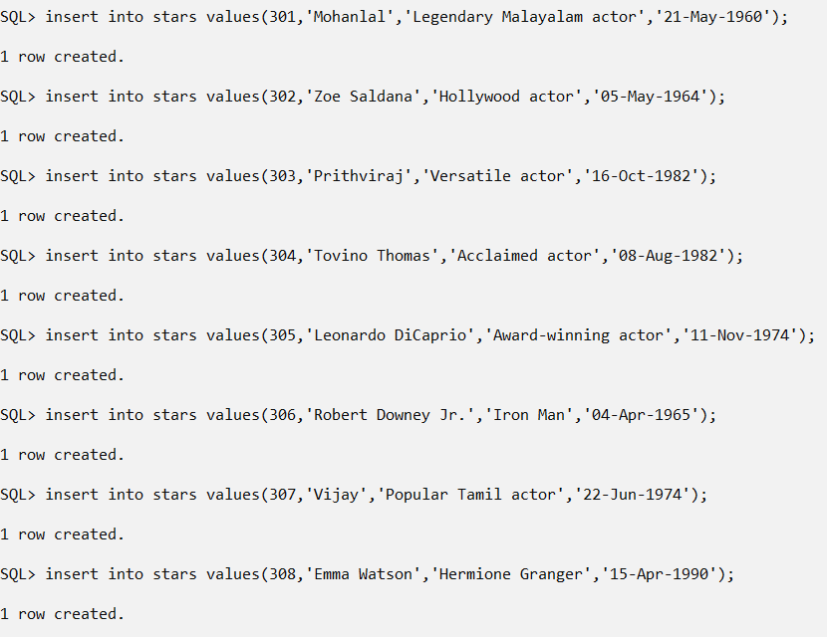
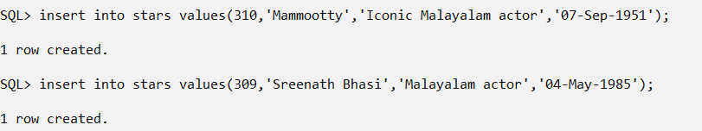
MoviesDirectors Table
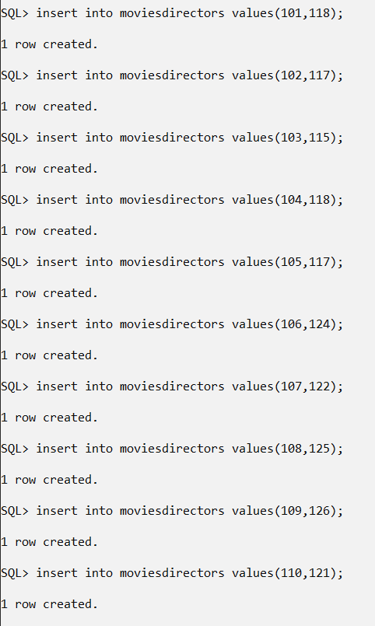

Moviesstars Table
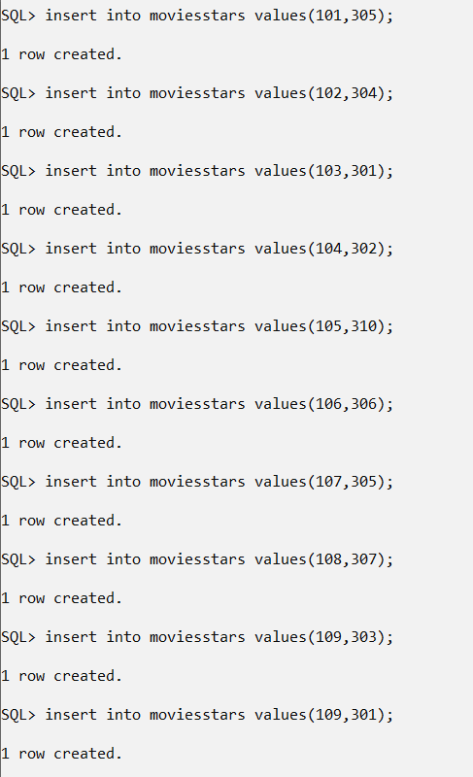

- Change value of Hit to 1 where ‘Votes’ greater than or equal to 90.

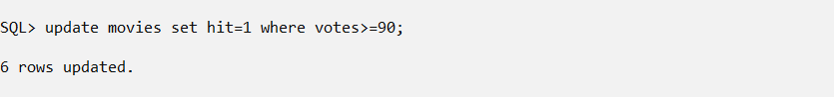

- Create table IndustryHit with the following columns:
Id
Title
Releasedate
Language
Votes
Gross

The data types and null characteristics for these columns should be
the same as the corresponding columns in the Movies table
described at the beginning of the lab exercise.

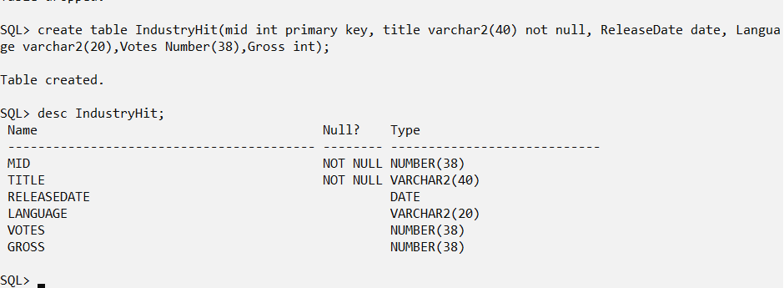

- New movies hit the box office; their data is as follows:
    - Id: 1014, 1021, 1032
    - Title: 2018: Everyone is a Hero, Oppenheimer, Maamannan
    - Releasedate: 5 May 2023, 21 July 2023, 29 June 2023
    - Language: Malayalam, English, Tamil
    - Votes: 97, 96, 95
    - Gross: 750000000, 500000000, 505000000
    - Add the new employees to the IndustryHit table.

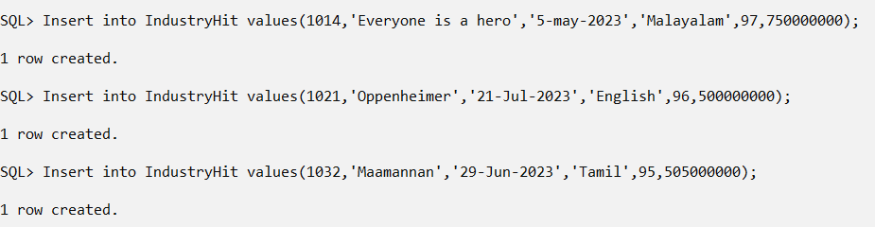

- Insert data into the new IndustryHit table.

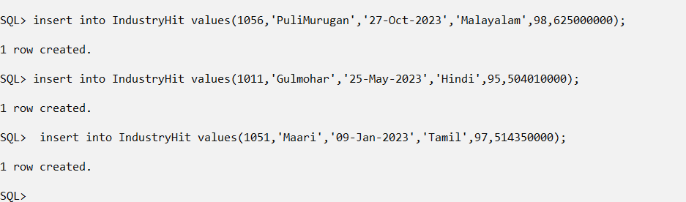

- Insert data into the IndustryHit table by copying the appropriate columns in the Movies table for those Movies that have Votes greater than or equal to 95.

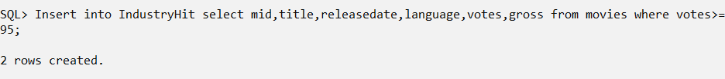

- Movie Oppenheimer got a Metascore of 80. Make the appropriate data change.

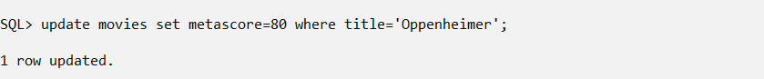

- Delete all movies whose Metascore is less than 50.

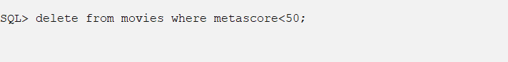

- Movie ‘Voice Of Sathyanathan’ was released.
    - For ‘Voice Of Sathyanathan’ enter the following data:
      - Id: 1015
      - Title: Voice Of Sathyanathan
      - Releasedate: 28 July 2023
      - Image_url: https://m.media-amazon.com/imak2M_.jpg
      - Certificate: U
      - Runtime: 2.10
      - ImdbRating: 7.4
      - Description: A man's life becomes increasingly complicated after his neighbor is injured in a dispute over a fence.
      - Metascore: 60
      - Votes: 90
      - Gross: 109500000
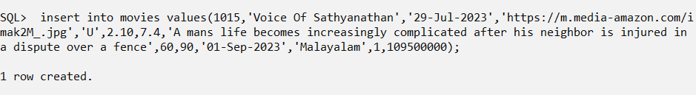

- Delete all rows from IndustryHit and drop the IndustryHit table.

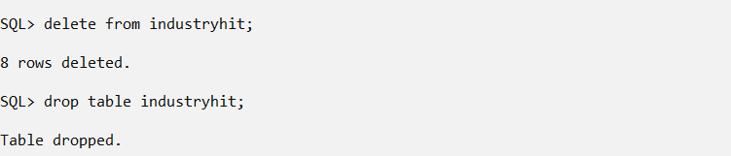

Activity # 3
Practice SQL Data Manipulation Language (DML) commands

Description : 3.2 Retrieval of data (Simple select query and select with ‘where’ options (include all relational and logical operators)
Date :
Query

- List details of all movies

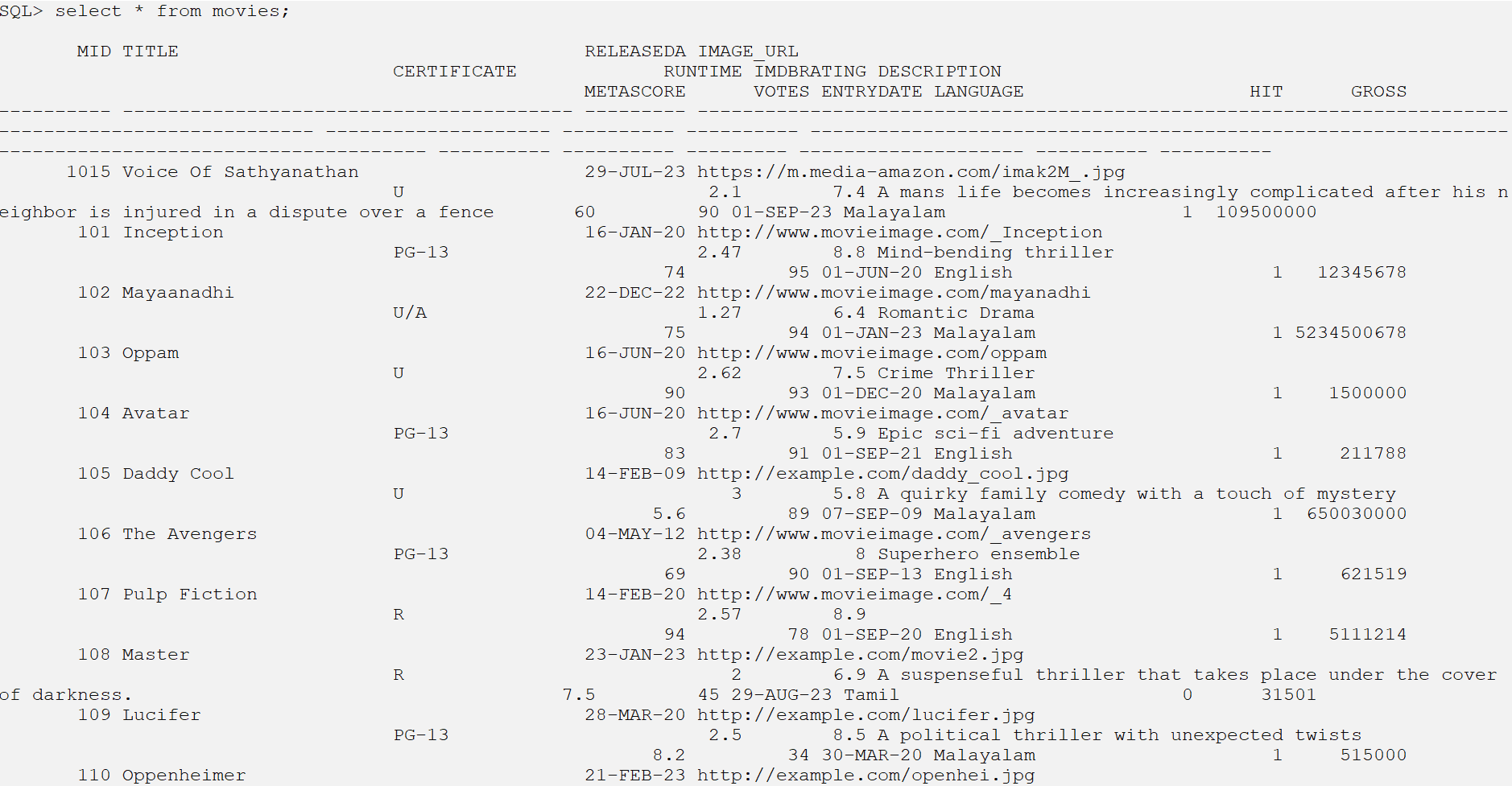

- List Title, Votes, ReleaseYear, Gross where Gross collection greater than 5000,000,00. Sequence the results in descending order by Gross.

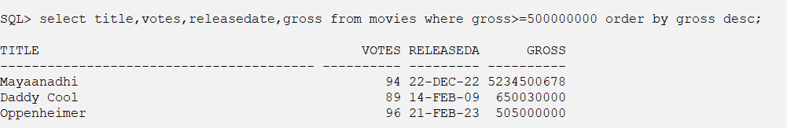

- Retrieve the titles and years of Tamil movies released in 2022.

- Get the titles, years, and meta scores of movies sorted in descending order of meta scores.
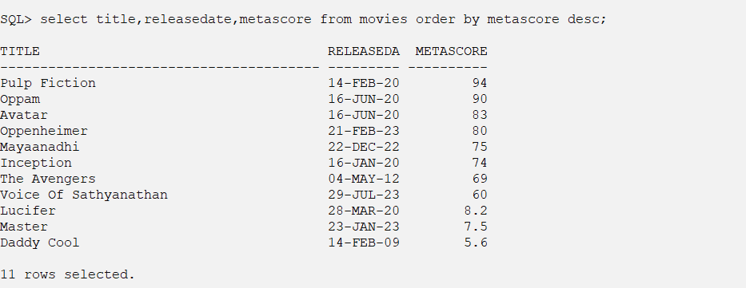

- List titles, years, languages, dates and votes of all Malayalam and English movies released before 2022 and ImdbRating less than 7. The list should be ordered by Title.

- List all the movies whose title starts with ‘Oppen’. Order the result by descending order of their id.

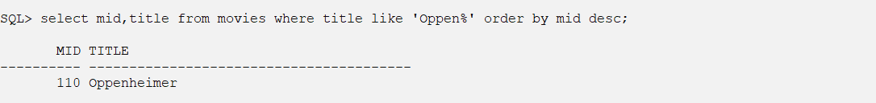

- List Hit movies released in 2022 and 2023. Order the result by ascending order of their Titles.

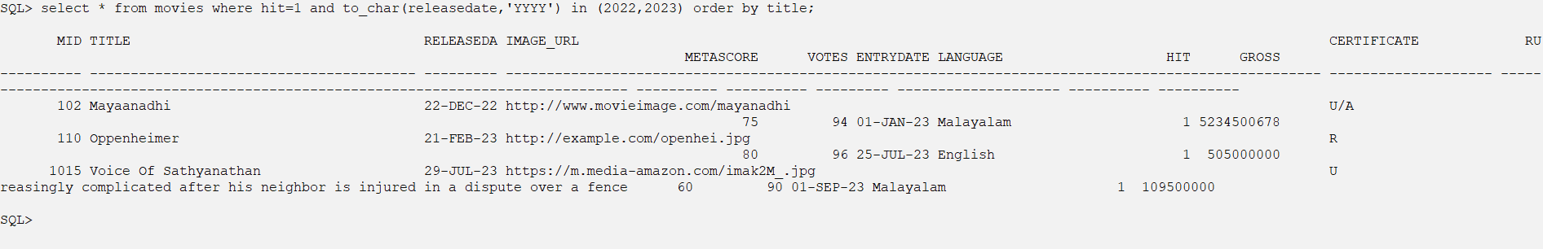

- Retrieve movies with a runtime between 1.5 and 2.5 hours.
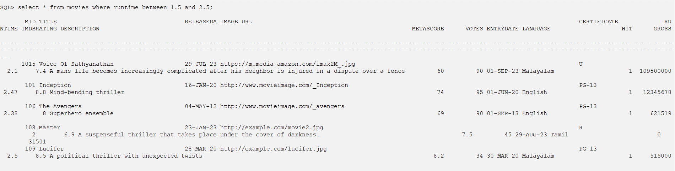
- Retrieve movies with Metascore ratings below 50 and IMDb ratings above 6.0.
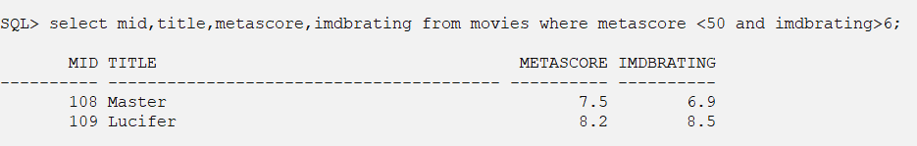
- Retrieve movies with no description provided.
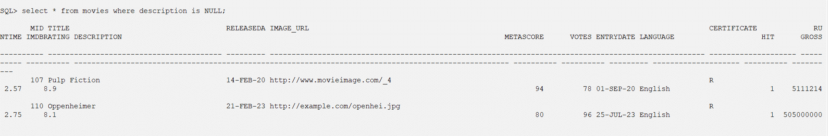

Activity # 3
Practice SQL Data Manipulation Language (DML) commands

Description : 3.3 Functions: Numeric Data, Character Conversion and Group functions

Date :
Query

- Illustrate the different numeric functions using dual table (power, round, ceil, floor, abs, exp, greatest, least, mod, trunc, round, sign, sqrt etc.)
- Illustrate the character functions (upper, lower, initcap, length, concat, ascii, substr, ltrim, rtrim, trim, translate, instr, chr,Lpad,Rpadetc) using the table Movies.
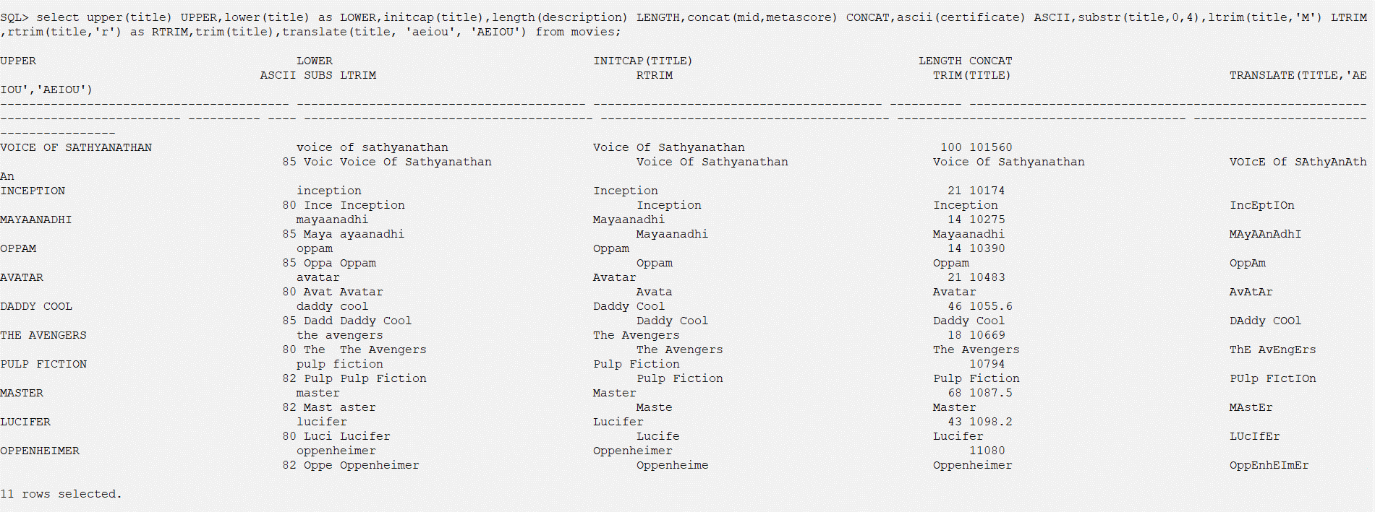
- Illustration of conversion functions- to_number, to_char(numberconversion), to_char(dateconversion)
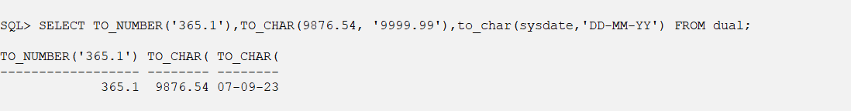
- Count the total no. of Movies
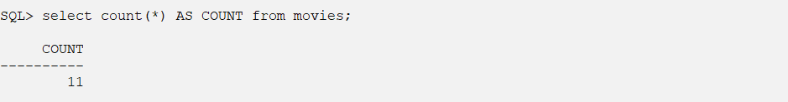

- Calculate the average votes of movies.
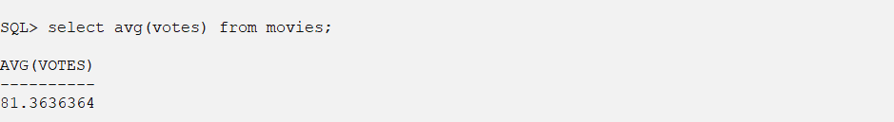

- Determine the maximum and minimum collection of movies. Rename the output as Max_Coll and Min_Coll respectively.
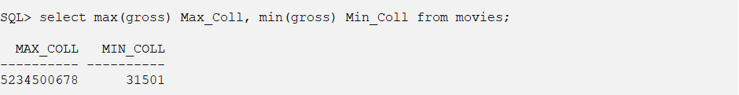

- Count the number of movies crossed the collection 50,00,00,000.
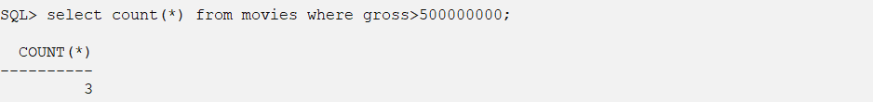

- Count the hit movies of 2021.
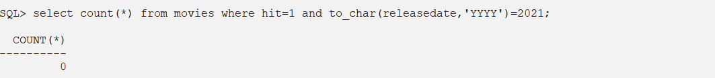

Activity # 3
Practice SQL Data Manipulation Language (DML) commands

Description : 3.4 Data manipulations using date functions
Date :
Query

- Provide a list of all movies which were released on June 16, 2020. Display the year and month of the released date and the Id. Sort the result by Id. Name the derived columns YEAR and MONTH.

- List the number of months between release date and entry date of each movie.

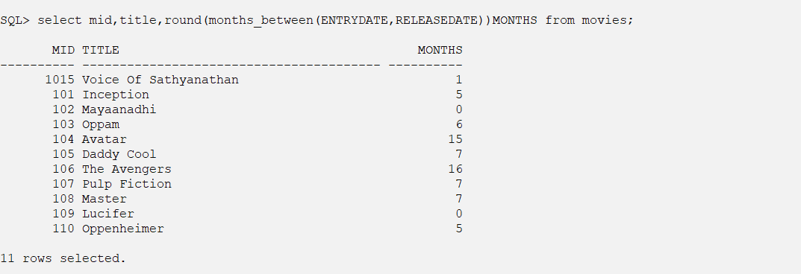
- List the Entry_date in the format ‘DD-Month-YY’.

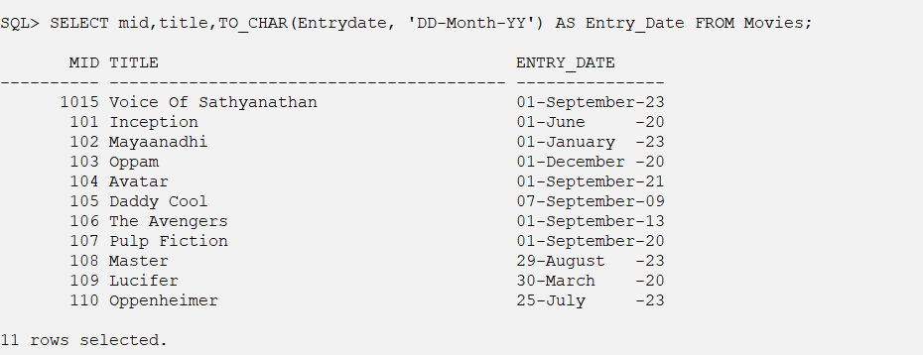

- List the date, 8 days after today’s date.

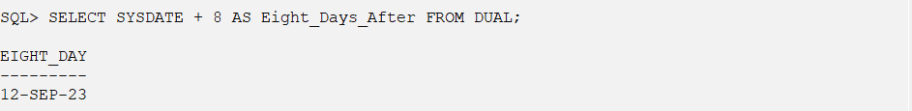

- List all the movies which were released in the month of February.

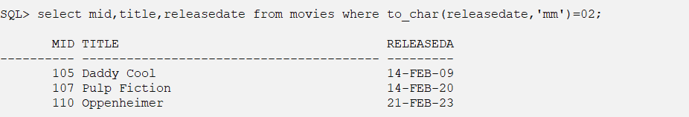

- Illustrate the different date functions using dual table (to_date, Add_months, last_day, months_between, next_day, round etc.)

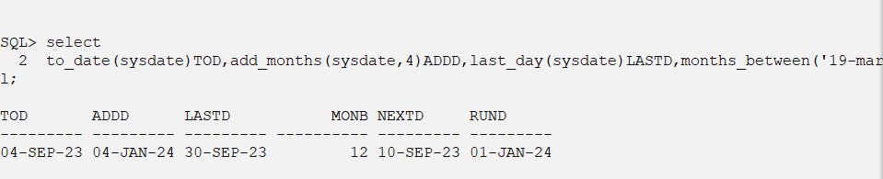

- Illustration of special date formats using to_char function (use of th,sp,spth)

- Calculate the total gross earnings for movies released after June 16, 2020.

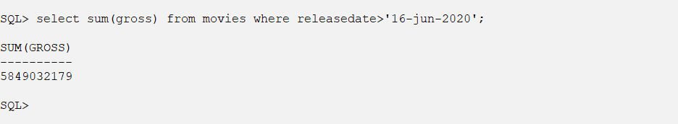

Activity # 3
Practice SQL Data Manipulation Language (DML) commands

Description : 3.5 Set Operations
Date :
Query

- Create a new table IndustryHit (Id, title, genre, Certificate, Gross, Releasedate). Insert some movies from Movies table and some new movies in the new table IndustryHit.

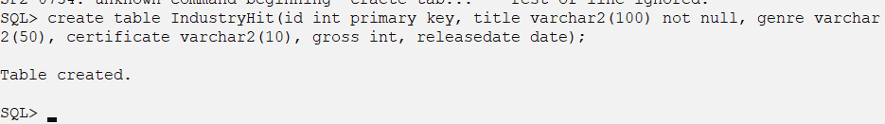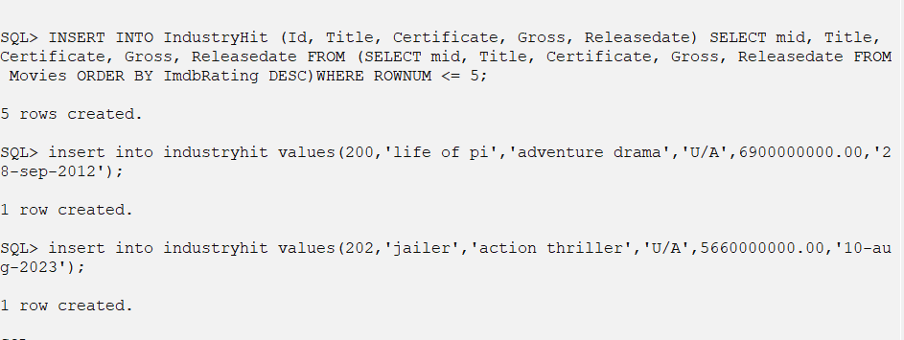
- Retrieve the titles of all movies and industry hits which are in the action thriller genre.

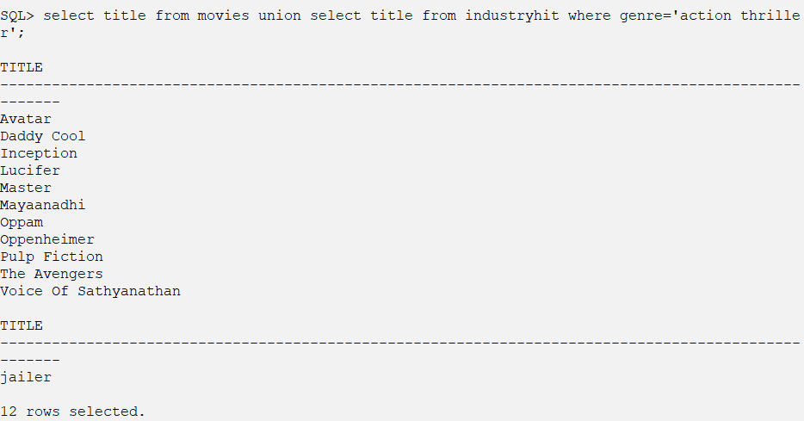
- Retrieve the titles of all movies including industry hits.

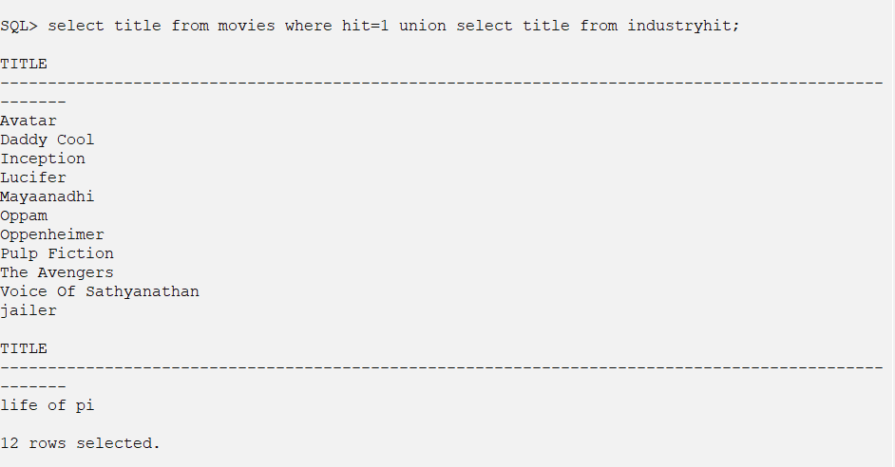
- Retrieve the titles of all movies which are not industry hits.

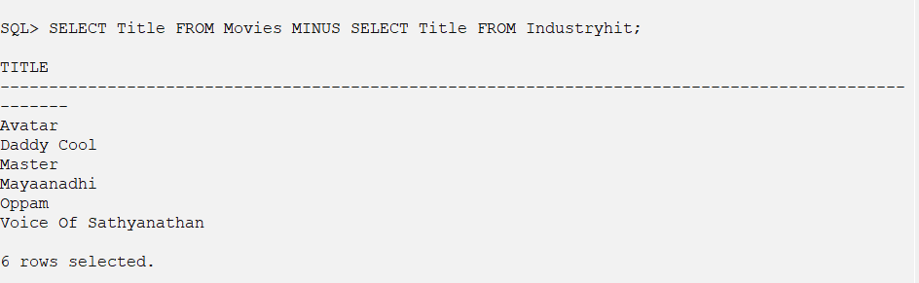

Activity # 3
Practice SQL Data Manipulation Language (DML) commands

Description : 3.6 Illustration of Group By having clause
Date :
Query

- For all genres, display genre type and the sum of all Gross for each genre. Name the derived column SUM_COLL.

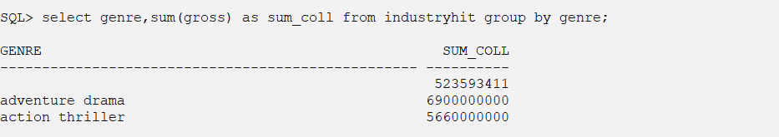
- For all genres, display the genre type and the number of titles. Name the derived column TITLE_COUNT.

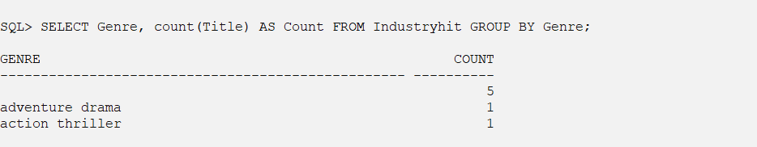

- Display the genres which have more than 3 titles.
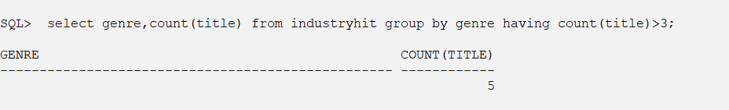
- Retrieve the total number of movies released in each year, only for years with at least 5 movies.

- List the certificates along with the number of movies for each certificate, but only show certificates with more than 3 movies.

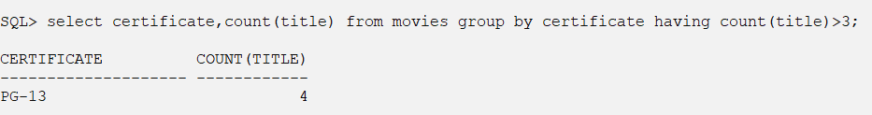

- Show the total gross earnings for each certificate, but only for certificates with total gross greater than $1 million.

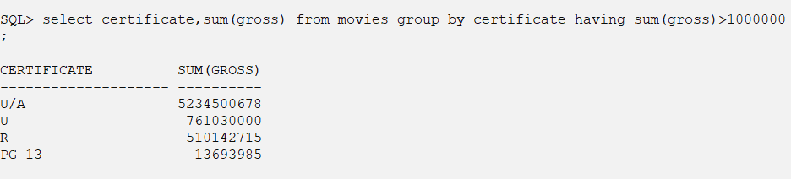

- List the release years with the highest number of movies and the corresponding movie count, limited to the top 3 years.

Activity # 3
Practice SQL Data Manipulation Language (DML) commands

Description : 3.7 Sub queries
Date :
Query

- Retrieve the titles and runtime of movies with the highest Metascore.

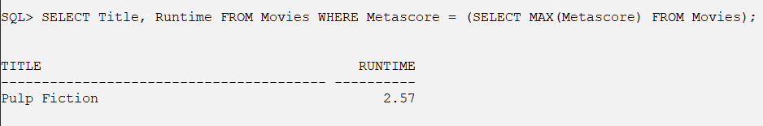
- List the titles of movies with a Gross amount greater than the average Gross amount of all movies.

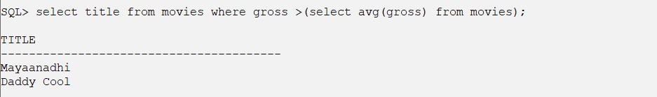
- Retrieve the titles and descriptions of movies with a Metascore lower than the average Metascore.

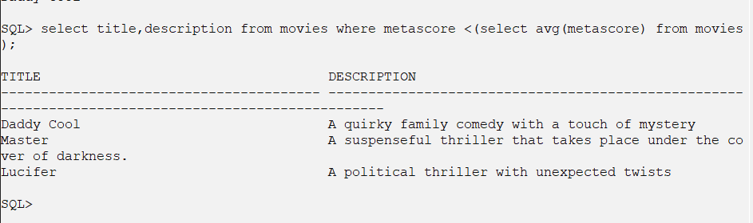
- List the movie titles and their IMDb ratings for movies released in the year with the highest average IMDb rating.

- Retrieve the movie titles and their IMDb ratings for movies that have a Metascore greater than twice their IMDb rating.

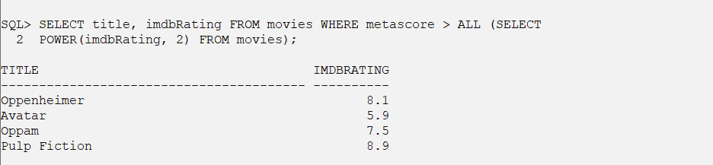
- Find the title and gross amount of the top 3 highest-grossing movies.

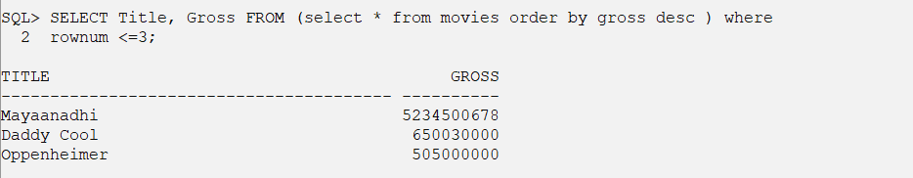
- Calculate the total number of votes received by movies released in the year 2022.

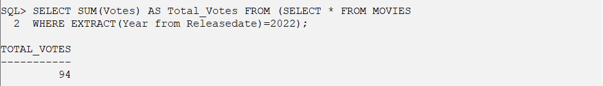
- List the titles and certificate ratings of movies that have an IMDb rating below the average IMDb rating.

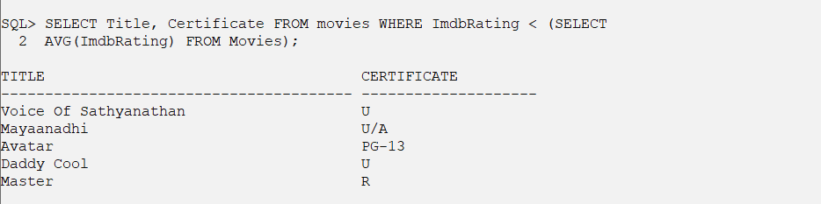

Activity # 3
Practice SQL Data Manipulation Language (DML) commands

Description : 3.8 Views
Date : 28-09-2023
Query

- Create a view called MovieDetails that combines information from the Movies, Directors, and Stars tables to display movie titles, directors' names, and the names of stars who acted in those movies.

SQL> CREATE VIEW MovieDetails as select title, d.name DirectorName, s.name StarName from movies m,directors d,stars s,moviesstars ms, moviesdirectors md where m.mid=ms.mid and d.did=md.did and s.sid=ms.sid and m.mid=md.mid;

View created.

SQL> SELECT * FROM MovieDetails;

TITLE DIRECTORNAME STARNAME
---------------------------------------- ------------------------------ ----------------------------------------
Inception Christopher Nolan Leonardo DiCaprio
Mayaanadhi Aashiq Abu Tovino Thomas
Oppam Priyadarshan Mohanlal
Avatar Christopher Nolan Zoe Saldana
Daddy Cool Aashiq Abu Mammootty
The Avengers Robert Zemeckis Robert Downey Jr.
Pulp Fiction Ridley Scott Leonardo DiCaprio
Master Lokesh Kanagaraj Vijay
Lucifer Prithviraj Sukumaran Mohanlal
Lucifer Prithviraj Sukumaran Prithviraj

10 rows selected.

- Create a view called HighlyRatedMovies that displays movies with IMDb ratings greater than 8.0, including their titles and ratings.

SQL> Create View HighlyratedMovies as select title,imdbrating from movies where imdbrating>8;

View created.

SQL> SELECT * FROM HighlyRatedMovies;

TITLE IMDBRATING
---------------------------------------- ----------
Inception 8.8
Pulp Fiction 8.9
Lucifer 8.5
Oppenheimer 8.1

- Create a view called DirectorMovies that provides a list of directors along with the number of movies they have directed.

SQL> Create View DirectorMovies as select d.name Director,count(*) No_of_Movies from moviesdirectors md,directors d where d.did=md.did group by d.name;

View created.

SQL> select * from DirectorMovies;

DIRECTOR NO_OF_MOVIES
------------------------------ ------------
Prithviraj Sukumaran 1
Lokesh Kanagaraj 1
Martin Scorsese 1
Robert Zemeckis 1
Christopher Nolan 2
Aashiq Abu 2
Ridley Scott 1
Priyadarshan 1

8 rows selected.

- Create a view called StarMovies that displays stars' names and the titles of movies they have acted in.

SQL> Create View StarsMovies as select s.name Stars,m.title Movie from stars s,movies m,moviesstars ms where m.mid=ms.mid and s.sid=ms.sid;

View created.

SQL> Select * from StarsMovies;

STARS MOVIE
---------------------------------------- ----------------------------------------
Leonardo DiCaprio Inception
Tovino Thomas Mayaanadhi
Mohanlal Oppam
Zoe Saldana Avatar
Mammootty Daddy Cool
Robert Downey Jr. The Avengers
Leonardo DiCaprio Pulp Fiction
Vijay Master
Prithviraj Lucifer
Mohanlal Lucifer

10 rows selected.

- Create a view called LongestMovies that lists the titles of movies with the longest runtimes (duration).

SQL> Create View LongestMovies as select title,runtime from movies where runtime=(select max(runtime) from movies);

View created.

SQL> Select * from LongestMovies;

TITLE RUNTIME
---------------------------------------- ----------
Daddy Cool 3

- Create a view called LanguageDistribution that shows the distribution of movies based on the languages they were released in, including the count of movies for each language.

SQL> Create view LanguageDistribution as select language,count(*) COUNT from movies group by language;

View created.

SQL> Select * from LanguageDistribution;

LANGUAGE COUNT
-------------------- ----------
Malayalam 5
Tamil 1
English 5

- Create a view called GrossEarnings that displays movies with their titles and gross earnings, sorted by earnings in descending order.

SQL> Create View GrossEarnings as select title,gross from movies order by gross desc;

View created.

SQL> Select * from GrossEarnings;

TITLE GROSS
---------------------------------------- ----------
Mayaanadhi 5234500678
Daddy Cool 650030000
Oppenheimer 505000000
Voice Of Sathyanathan 109500000
Inception 12345678
Pulp Fiction 5111214
Oppam 1500000
The Avengers 621519
Lucifer 515000
Avatar 211788
Master 31501

11 rows selected.

- Create a view called IndustryHitMovies that shows the titles and release dates of industry hit movies.

SQL> Create View IndustryHitMovies as select title Movie,Releasedate from movies where hit=1;

View created.

SQL> Select * from IndustryHitMovies;

MOVIE RELEASEDA
---------------------------------------- ---------
Voice Of Sathyanathan 29-JUL-23
Inception 16-JAN-20
Mayaanadhi 22-DEC-22
Oppam 16-JUN-20
Avatar 16-JUN-20
Daddy Cool 14-FEB-09
The Avengers 04-MAY-12
Pulp Fiction 14-FEB-20
Lucifer 28-MAR-20
Oppenheimer 21-FEB-23

10 rows selected.

- Create a view called MovieVotes that displays movies along with their titles and the number of votes they have received.

SQL> Create View MovieVotes as select title movie,votes from movies;

View created.

SQL> Select * from MovieVotes;

MOVIE VOTES
---------------------------------------- ----------
Voice Of Sathyanathan 90
Inception 95
Mayaanadhi 94
Oppam 93
Avatar 91
Daddy Cool 89
The Avengers 90
Pulp Fiction 78
Master 45
Lucifer 34
Oppenheimer 96

11 rows selected.

- Create a view called CertifiedMovies that lists movies with their titles and certificates (e.g., U/A, U).

SQL> Create View CertifiedMovies as select title Movie,Certificate from movies;

View created.

SQL> Select * from CertifiedMovies;

MOVIE CERTIFICATE
---------------------------------------- --------------------
Voice Of Sathyanathan U
Inception PG-13
Mayaanadhi U/A
Oppam U
Avatar PG-13
Daddy Cool U
The Avengers PG-13
Pulp Fiction R
Master R
Lucifer PG-13
Oppenheimer R
11 rows selected.
Activity # 4
Practice PL/SQL

Description : 4.1 Introduction to PL/SQL
Date : 7-09-2023
Query
            - Write a PL/SQL code block to calculate the area of a circle for a value of radius varying from 3 to 7. Store the radius and corresponding values of calculated area in an empty table named Areas, consisting of two columns Radius and Area.

SQL> CREATE TABLE Circle(Radius NUMBER, Area Number);

Table created.

SQL> edit E:\MCA_2333\pg1.sql

DECLARE
i number;
a Number;
BEGIN
for i
in 3..7
loop
a:=3.14*i*i;
insert into circle values(i,a);
end loop;
END;
SQL> @ E:\MCA_2333\pg1.sql
12 /

PL/SQL procedure successfully completed.

SQL> select * from circle;

RADIUS AREA
---------- ----------
3 28.26
4 50.24
5 78.5
6 113.04
7 153.86

            - Write a PL/SQL block of code for inverting a number accepted from the console.

SQL> edit E:\MCA_2333\pg2.sql

DECLARE
n number;
r number;
BEGIN
n:=&n;
r:=0;
while n>0 loop
r:=(r*10)+mod(n,10);
n:=floor(n/10);
end loop;
dbms_output.put_line('Inverted Number : '||154);
END;

SQL> @ E:\MCA_2333\pg2.sql
13 /
Enter value for n: 451
old 5: n:=&n;
new 5: n:=451;
Inverted Number : 154

PL/SQL procedure successfully completed.

            - Write a PL/SQL code block that will accept an account number from the user and debit an amount of Rs.2000 from the account if the account has a minimum balance of 500 after the amount is debited. The process is fired on the Accounts table.

SQL> create table account(accno int,name Varchar2(15),balaance number(10,2));
Table created.
SQL> insert into account values(3004,'Mariya',200000);
1 row created.
SQL> insert into account values(3001,'Megha',500600);
1 row created.
SQL> insert into account values(3001,'Merin',1000);
1 row created.
SQL> edit E:\MCA_2333\pg3.sql

declare
acno int;
bal number(10,2);
begin
acno:=&acno;
select balaance into bal from account where accno=acno;
if bal-2000>500 then
bal:=bal-2000;
update account set balaance=bal where accno=acno;
else
dbms_output.put_line('Transaction Not posiible');
end if;
end;

SQL> @ E:\MCA_2333\pg3.sql
14 /
Enter value for acno: 3004
old 5: acno:=&acno;
new 5: acno:=3004;

PL/SQL procedure successfully completed.

SQL> select * from account;

ACCNO NAME BALAANCE
---------- --------------- ----------
3004 Mariya 198000
3001 Megha 500600
3001 Merin 1000

            - Write a PL/SQL block of code that updates the salaries of Maria Jacob and Albert by Rs. 2000/- and Rs.2500/- respectively. Then check to see that the total salary does not exceed 75000. If the total salary is greater than 75000, then undo the updates made to salaries of both. (Use savepoint, rollback and commit).

SQL> create table employ(empno int,name varchar2(20),salary number(10,2));

Table created.

SQL> insert into employ values(101,'Maria',20000);

1 row created.

SQL> insert into employ values(102,'Albert',15000);

1 row created.

SQL> insert into employ values(103,'Megha',20000);

1 row created.

SQL> edit E:\MCA_2333\pg4.sql

declare
s number(10,2);
begin
savepoint s1;
update employ set salary=salary+2000 where empno=101 or empno=102;
select sum(salary) into s from employ;
if s >75000 then
rollback to s1;
dbms_output.put_line('Rollbacked');
else
commit;
end if;
end;

SQL> @ E:\MCA_2333\pg4.sql
14 /

PL/SQL procedure successfully completed.

Activity # 4
Practice PL/SQL

Description : 4.2.1 Illustration of Implicit Cursors
Date : 21-09-2023
Query
- Write a PL/SQL block to accept an employee number and update the salary of that employee to raise the salary by 0.15. Display appropriate message based on the existence of the record in the employee table.
SQL> edit E:\MCA_2333\pg5.sql

declare
begin
update employee set salary=salary+(salary*0.15) where empno=&empno;
if sql%found then
dbms_output.put_line(sql%rowcount||' records updated');
end if;
end;

SQL> select empno,salary from employee where empno='E0340';

EMPNO SALARY
---------- ----------
E0340 900

SQL> @ E:\MCA_2333\pg5.sql
10 /
Enter value for empno: 'E0340'
old 4: update employee set salary=salary+(salary*0.15) where empno=&empno;
new 4: update employee set salary=salary+(salary*0.15) where empno='E0340';
1 records updated

PL/SQL procedure successfully completed.

SQL> select empno,salary from employee where empno='E0340';

EMPNO SALARY
---------- ----------
E0340 1035

- The HRD manager decides to raise the salary of employees working as ‘analyst’ by 0.15. Write a cursor to update the salary of the employees. Display the no. of employee records that has been modified.

SQL> edit E:\MCA_2333\pg6.sql

declare
begin
update employee set salary=salary+(salary*0.15) where job='ANALYST';
if sql%found then
dbms_output.put_line(sql%rowcount||' records updated');
end if;
end;

SQL> @ E:\MCA_2333\pg6.sql
10 /
2 records updated
PL/SQL procedure successfully completed.

Activity # 4
Practice PL/SQL

Description : 4.2.2 Illustration of Explicit Cursors
Date : 21-09-2023
Query

- Write an explicit cursor to display the name,department, salary of the first 5 employees getting the highest salary.

SQL> edit E:\MCA_2333\pg15.sql

declare
CURSOR empcur IS select * from (select empname,deptname,salary from employee e, department d where e.deptno=d.deptno order by salary desc ) where rownum<=5;
empv empcur%rowtype;
begin
dbms_output.put_line('Employee Details');
open empcur;
fetch empcur into empv;
while empcur%found loop
dbms_output.put_line('Empnname : '||empv.empname);
dbms_output.put_line('Department : '||empv.deptname);
dbms_output.put_line('Salary : '||empv.salary);
dbms_output.put_line('----------------------------');
fetch empcur into empv;
end loop;
close empcur;
end;
SQL> @ E:\MCA_2333\pg15.sql
17 /
Employee Details
Empnname : ARNOLD LEONARD AMON
Department : COMPUTER SERVICE DIVISION
Salary : 152750
----------------------------
Empnname : DONA ANICE SIBY
Department : COMPUTER SERVICE DIVISION
Salary : 46500
----------------------------
Empnname : PHILIP VINCENT
Department : PLANNING
Salary : 41250
----------------------------
Empnname : ALFRIN LUIZ
Department : SUPPORT SERVICES
Salary : 40175
----------------------------
Empnname : SHILVY K K
Department : INFORMATION CENTER
Salary : 38250
----------------------------

PL/SQL procedure successfully completed.

- The HRD manager decides to raise the salary of employees working as ‘analyst’ by 0.15. Whenever any such raise is given to the employees, a record for the same is maintained in the emp_raise table. It includes the employee number, the date when the raise was given and actual raise. Write a PL/SQL block to update the salary of the employees and insert a record in the emp_raise table.
Emp_raise(empcode, raisedate,raise_amt)

SQL> create table emp_raise (empcode varchar(10), raisedate date, raise_amt number(10,2));

Table created.

SQL> edit E:\MCA_2333\pg16.sql

– code
declare
CURSOR empcur IS select * from employee where job='ANALYST';
empv empcur%rowtype;
sal number(10,2);
begin
open empcur;
fetch empcur into empv;
while empcur%found loop
sal:=(empv.salary*0.15)+empv.salary;
insert into emp_raise values(empv.empno,sysdate,sal);
fetch empcur into empv;
end loop;
dbms_output.put_line(empcur%rowcount||' rows updated');
close empcur;
end;
SQL> @ E:\MCA_2333\pg16.sql
16 /
2 rows updated
PL/SQL procedure successfully completed.
SQL> select * from emp_raise;
EMPCODE RAISEDATE RAISE_AMT
---------- --------- ----------
E0130 23-SEP-23 27370
E0140 23-SEP-23 32683

Activity # 4
Practice PL/SQL

Description : 4.3 Illustration of Procedures
Date : 07-10-2023
Query

- Write a PL/SQL block which makes use of a stored procedure Proj_emp ( emp_name varchar2(50) ) which finds all the details of the projects involved by the given employee.

edit C:\Users\cclab29\OneDrive\mca2333\p22.sql
create or replace procedure Proj_emp(ename in varchar)
as
CURSOR projcur IS select ep.empno,empname,ep.projno,projname from emp_pro ep,project p,employee e where e.empname=ename and ep.empno=e.empno AND p.projno=ep.projno;
empv projcur%rowtype;

begin
dbms_output.put_line('Project Details');
open projcur;
fetch projcur into empv;
while projcur%found loop
dbms_output.put_line('Empnname : '||empv.empname);
dbms_output.put_line('ProjNo : '||empv.projno);
dbms_output.put_line('projname : '||empv.projname);
dbms_output.put_line('----------------------------');
fetch projcur into empv;
end loop;
close projcur;
end;

SQL> @ C:\Users\cclab29\OneDrive\mca2333\p22.sql
20 /

Procedure created.
SQL> execute PROJ_EMP('RIYA TONEY');
Project Details
Empnname : RIYA TONEY
ProjNo : AD3112
projname : PERSONNEL PROGRAMMING
----------------------------
Empnname : RIYA TONEY
ProjNo : IF2000
projname : USER EDUCATION
----------------------------

PL/SQL procedure successfully completed.

- Write a procedure to check whether a string is a palindrome . Call the procedure to list all the palindrome names in the employee table.

edit C:\Users\cclab29\OneDrive\mca2333\p23.sql

create or replace procedure palindrome(n in varchar)
as
s varchar2(30);
begin
select reverse(n) into s from dual;
if n=s then
dbms_output.put_line(n);
end if;
end;

SQL> @ C:\Users\cclab29\OneDrive\mca2333\p23.sql
10 /

Procedure created.
SQL> edit C:\Users\cclab29\OneDrive\mca2333\p23_main.sql
declare
cursor enamcur is select empname from employee;
name employee.empname%type;
begin
open enamcur;
fetch enamcur into name;
while enamcur%found loop
palindrome(name);
fetch enamcur into name;
end loop;
close enamcur;
end;

SQL> set serveroutput on;
SQL> @ C:\Users\cclab29\OneDrive\mca2333\p23_main.sql
13 /
ABCCBA

PL/SQL procedure successfully completed.

- Modify the program using cursor to display the name of the employee and increment percentage of salary according to their working experiences, by calling a procedure for computing the increment based on years of experience using IN and OUT parameters. *Hint: Years of experience and Salary are the IN parameters and increment is the OUT parameter.

SQL> edit C:\Users\cclab29\OneDrive\mca2333\p24.sql
create or replace procedure incre(y in number,sal in out number)
as
begin
if y>3 then
sal:=10;
elsif y>2 then
sal:=5;
else
sal:=2;
end if;
end;

SQL> @ C:\Users\cclab29\OneDrive\mca2333\p24.sql
15 /
Procedure created.
SQL> edit C:\Users\cclab29\OneDrive\mca2333\p24_main.sql
declare
cursor empcur is select empname,hiredate,salary from employee;
emp empcur%rowtype;
y number;
yr number;
n number;
begin
open empcur;
select to_char(sysdate,'YYYY') into y from dual;
fetch empcur into emp;
while empcur%found loop
select to_char(emp.hiredate,'YYYY') into yr from employee where empname=emp.empname;
n:=y-yr;
incre(y,emp.salary);
dbms_output.put_line('Empname : '||emp.empname);
dbms_output.put_line('Hiredate : '||emp.hiredate);
dbms_output.put_line('Year : '||y);
dbms_output.put_line('Increment : '||emp.salary);
dbms_output.put_line('-----------------------------');
fetch empcur into emp;
end loop;
end;

SQL> @ C:\Users\cclab29\OneDrive\mca2333\p24_main.sql
25 /
Empname : PHILIP VINCENT
Hiredate : 10-SEP-02
Year : 2023
Increment : 10
-----------------------------

Activity # 4
Practice PL/SQL

Description : 4.4 Illustration of functions
Date : 10-10-2023
Query
- Write a function to find the reverse of EmpNo in Employee table and display the EmpNo and Reversed(Emp No) of the first 5 employees using an SQL Query.
SQL> edit C:\Users\cclab29\OneDrive\mca2333\func1.sql

CREATE OR REPLACE FUNCTION Reversed(empno in varchar2)
return varchar2
IS
rev varchar2(20);
BEGIN
select reverse(empno) into rev from dual;
return rev;
END;
SQL> @ C:\Users\cclab29\OneDrive\mca2333\func.sql
9 /
Function created.
SQL> select eno,ename,Reversed(eno) from employee where rownum<=5;

ENO ENAME REVERSED(ENO)
---------- ------------------- ------------------------
E0010 MEGHA 0100E

E0011 MARIYA 1100E

E0012 MERIN 2100E

E0013 SARA 3100E

E0014 JOHN 4100E

- Write a function that would check for the existence of an employee in the employee table given an EmpNo. If existing employee, check whether he is the manager of any department and display messages accordingly.
SQL> edit C:\Users\cclab29\OneDrive\mca2333\func2.sql

CREATE OR REPLACE FUNCTION CHECK_emp(empno in varchar2)
return varchar2
AS
j varchar2(20);
BEGIN
SELECT job into j from emp_tab where eno=empno;
if sql%notfound then
return('EMPLOYEE NOT FOUND');
elsif j='MANAGER' then
return('MANAGER');
else
return('NOT MANAGER');
end if;
END;
SQL> @ C:\Users\cclab29\OneDrive\mca2333\func2.sql
15 /
Function created.
SQL> select check_emp('E0010') from dual;
CHECK_EMP('E0010')
------------------------
NOT MANAGER
SQL> insert into emp_tab values ('E0020','SYED',9000, 'MANAGER');
1 row created.
SQL> select check_emp('E0020') from dual;
CHECK_EMP('E0020')
-------------------------
MANAGER

Activity # 4
Practice PL/SQL

Description : 4.5 Illustration of Triggers
Date : 20-10-2023
Query

- Consider the table Employee. Write PL/SQL statements to create a trigger when fired checks the operation performed on a table and based on the operation, a variable is assigned the value ‘update’ or ‘delete’. Previous values of the modified record of the table Employee are stored into the appropriate variables declared and inserted to the audit table AuditEmployee.

SQL> Create table AuditEmployee(eno varchar2(5),ename varchar2(20), esal number(10,2), job varchar2(20), Audit_action varchar2(20));

Table created.

SQL> edit C:\Users\cclab29\OneDrive\mca2333\p23.sql
Create or Replace TRIGGER trigaudit BEFORE delete or update on Emp_tab
for each row
DECLARE
audit_action varchar2(20);
BEGIN
if deleting then
audit_action:='DELETE';
elsif updating then
audit_action:='UPDATE';
end if;
insert into AuditEmployee values(:old.eno,:old.ename,:old.esal,:old.job,audit_action);
END;

SQL> @ C:\Users\cclab29\OneDrive\mca2333\p23.sql
13 /

Trigger created.

SQL> update emp_tab set esal=10000 where eno='E0013';

1 row updated.

SQL> delete from emp_tab where eno='E0013';

1 row deleted.

SQL> select * from AuditEmployee;

ENO ENAME ESAL JOB AUDIT_ACTION
----- ------------------- ---------- -------------- ---------------
E0013 SARA 17000 PROFESSOR DELETE
E0013 SARA 17000 PROFESSOR UPDATE

- Write PL/SQL statements to create a trigger which generates an error messages if the salary is below or beyond the valid range 0-5000 on the employee table. The triggering events are update and insert.

SQL> edit C:\Users\cclab29\OneDrive\mca2333\p24.sql
create or replace trigger Trig2 after INSERT OR UPDATE ON emp_tab
for each row
begin
if (:new.esal not between 0 and 5000 ) then
RAISE_APPLICATION_ERROR(-20500,'SALARY RANGE NOT BETWEEN 0 AND 5000');
END IF;
END;

SQL> @ C:\Users\cclab29\OneDrive\mca2333\pg27.sql
8 /
Trigger created.

SQL> update emp_tab set esal=6000 where eno='E0010';
update emp_tab set esal=6000 where eno='E0010'
*
ERROR at line 1:
ORA-20500: SALARY RANGE NOT BETWEEN 0 AND 5000
ORA-06512: at "MCA.TRIG2", line 3
ORA-04088: error during execution of trigger 'MCA.TRIG2'

- Write PL/SQL statements to create a trigger that limits the DML actions to the Employee table to weekdays from 8.30am to 6.30pm. If a user tries to insert/update/delete a row in the Employee table, a warning message will be prompted.

SQL> edit C:\Users\cclab29\OneDrive\mca2333\p25.sql
create or replace trigger mytrig1 BEFORE DELETE OR INSERT OR UPDATE ON emp_tab
begin
if (to_char(sysdate,'day') in ('sun','mon')) or (to_char(sysdate ,'hh:mi') not between '08:30' and '18:30') then
RAISE_APPLICATION_ERROR(-20500,'TABLE IS SECURED');
END IF;
END;

SQL> @ C:\Users\cclab29\OneDrive\mca2333\p25.sql
7 /
Trigger created.
SQL> insert into emp_tab values('E0013','SARA',17000,'PROFESSOR');
insert into emp_tab values('E0013','SARA',17000,'PROFESSOR')
*
ERROR at line 1:
ORA-20500: TABLE IS SECURED
ORA-06512: at "SYSTEM.UP_TRIG", line 3
ORA-04088: error during execution of trigger 'SYSTEM.UP_TRIG'

